Container Orchestration and Infrastructure Management

For

Online Shopping Grocery App

Submitted By

|  |  |  |
| --- | --- | --- |
| **Specialization** | **SAP ID** | **Name** |
| BTech CSE (CC&VT) NH | 500091910 | Hitendra Sisodia |
| BTech CSE (CC&VT) NH | 500091882 | Ujesh Sisodia |
| BTech CSE (CC&VT) NH | 500091901 | Priyanshu Tandon |
| BTech CSE (CC&VT) NH | 500091736 | Anirudh Srinivasan |



Department of Systemics

School Of Computer Science

UNIVERSITY OF PETROLEUM & ENERGY STUDIES,

DEHRADUN- 248007. Uttarakhand

**Submitted To: Submitted By:**

Ms.Avita Katal Ujesh Sisodia(500091882)

Assistant Professor (SG) Hitendra Sisodia(500091910)

School of Computer Science Priyanshu Tandon (500091901)

Anirudh Srinivasan (500091736)

**Assignment – 1 Recap**

Microservices created for the project

1. Customer: 8001
2. Products: 8002
3. Shopping: 8003
4. Proxy: 80 (Nginx Default Port No)

Each Microservices running individually at port 8001, 8002, 8003.

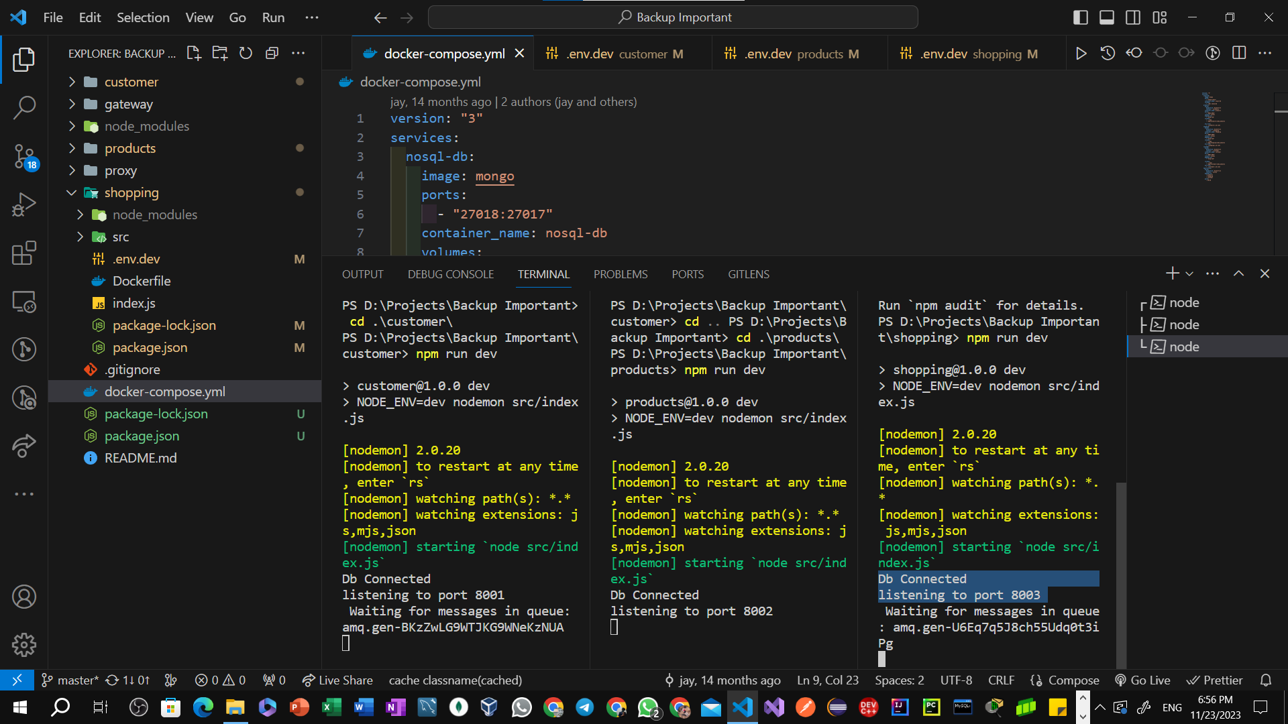

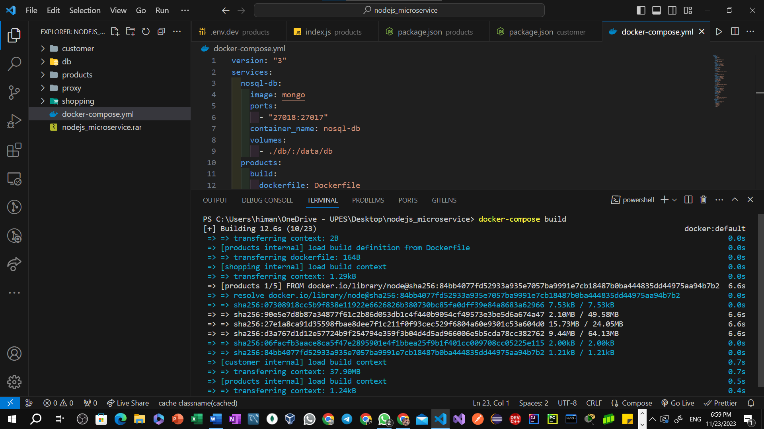Executing the below command initiates the Docker Compose build process, ensuring that each microservice is built with its dependencies and configurations. docker-compose build

Running All Microservices using single command.

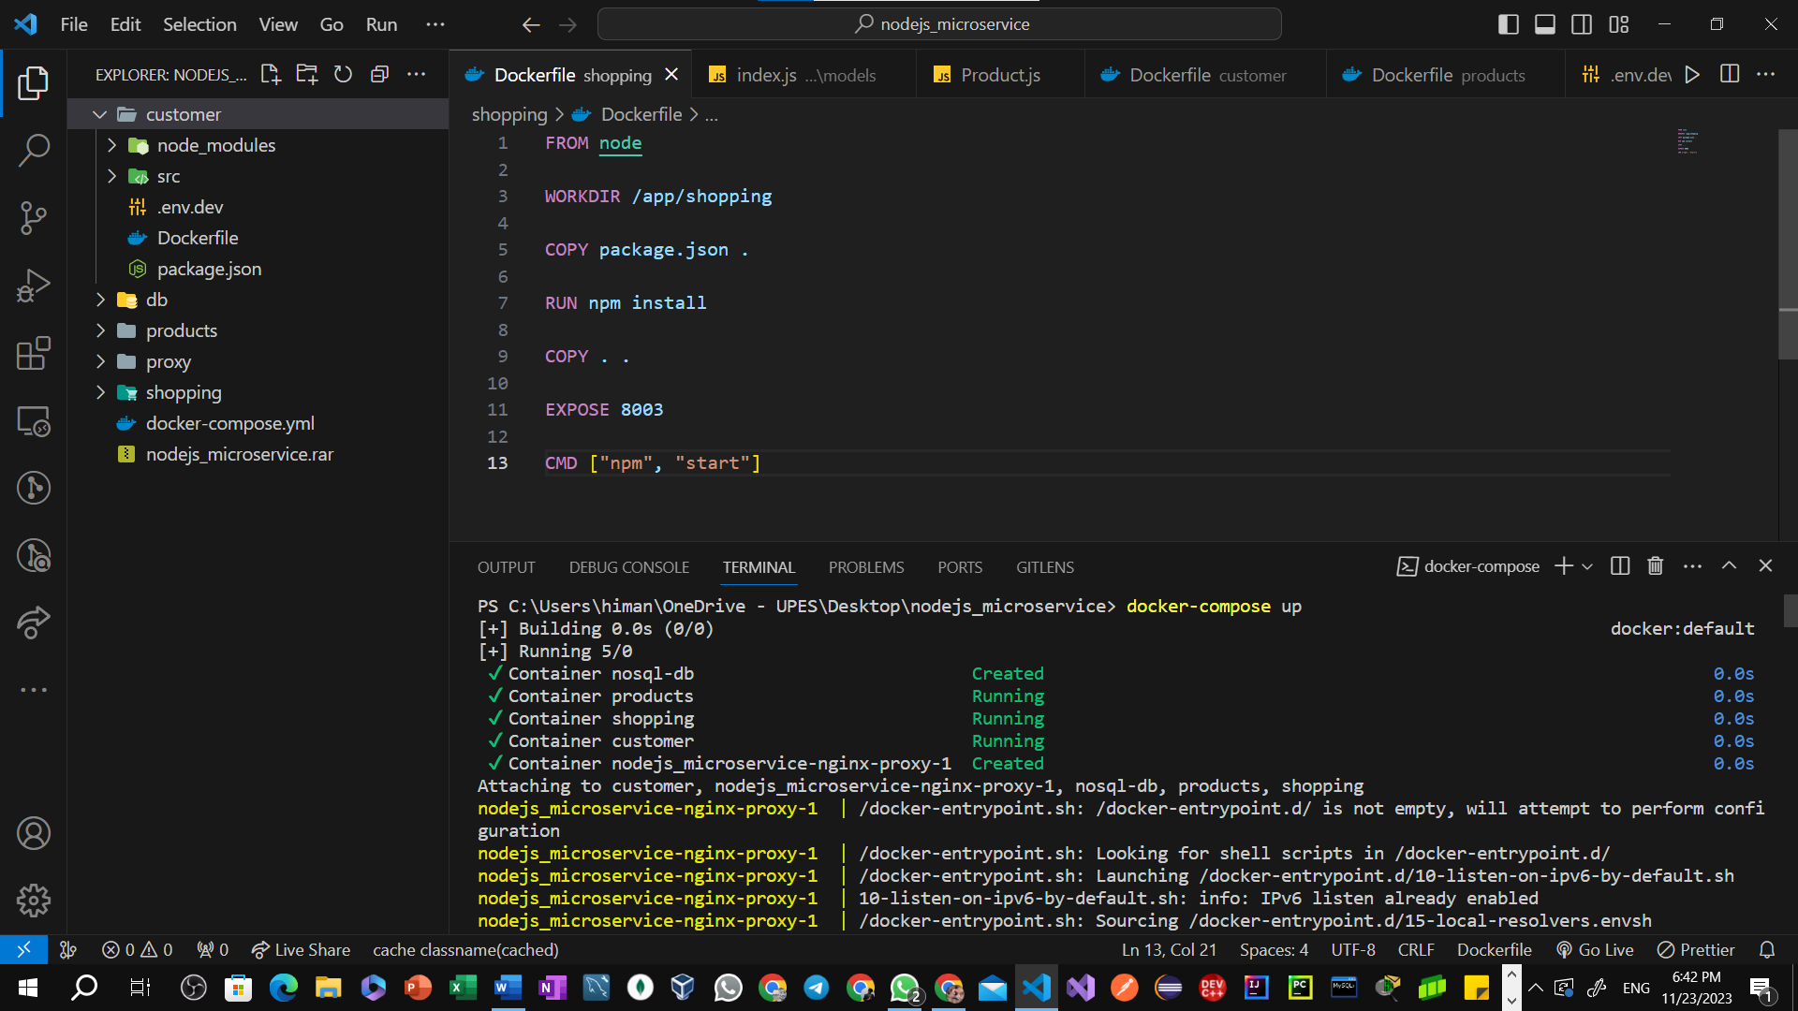

docker-compose up

Docker Images

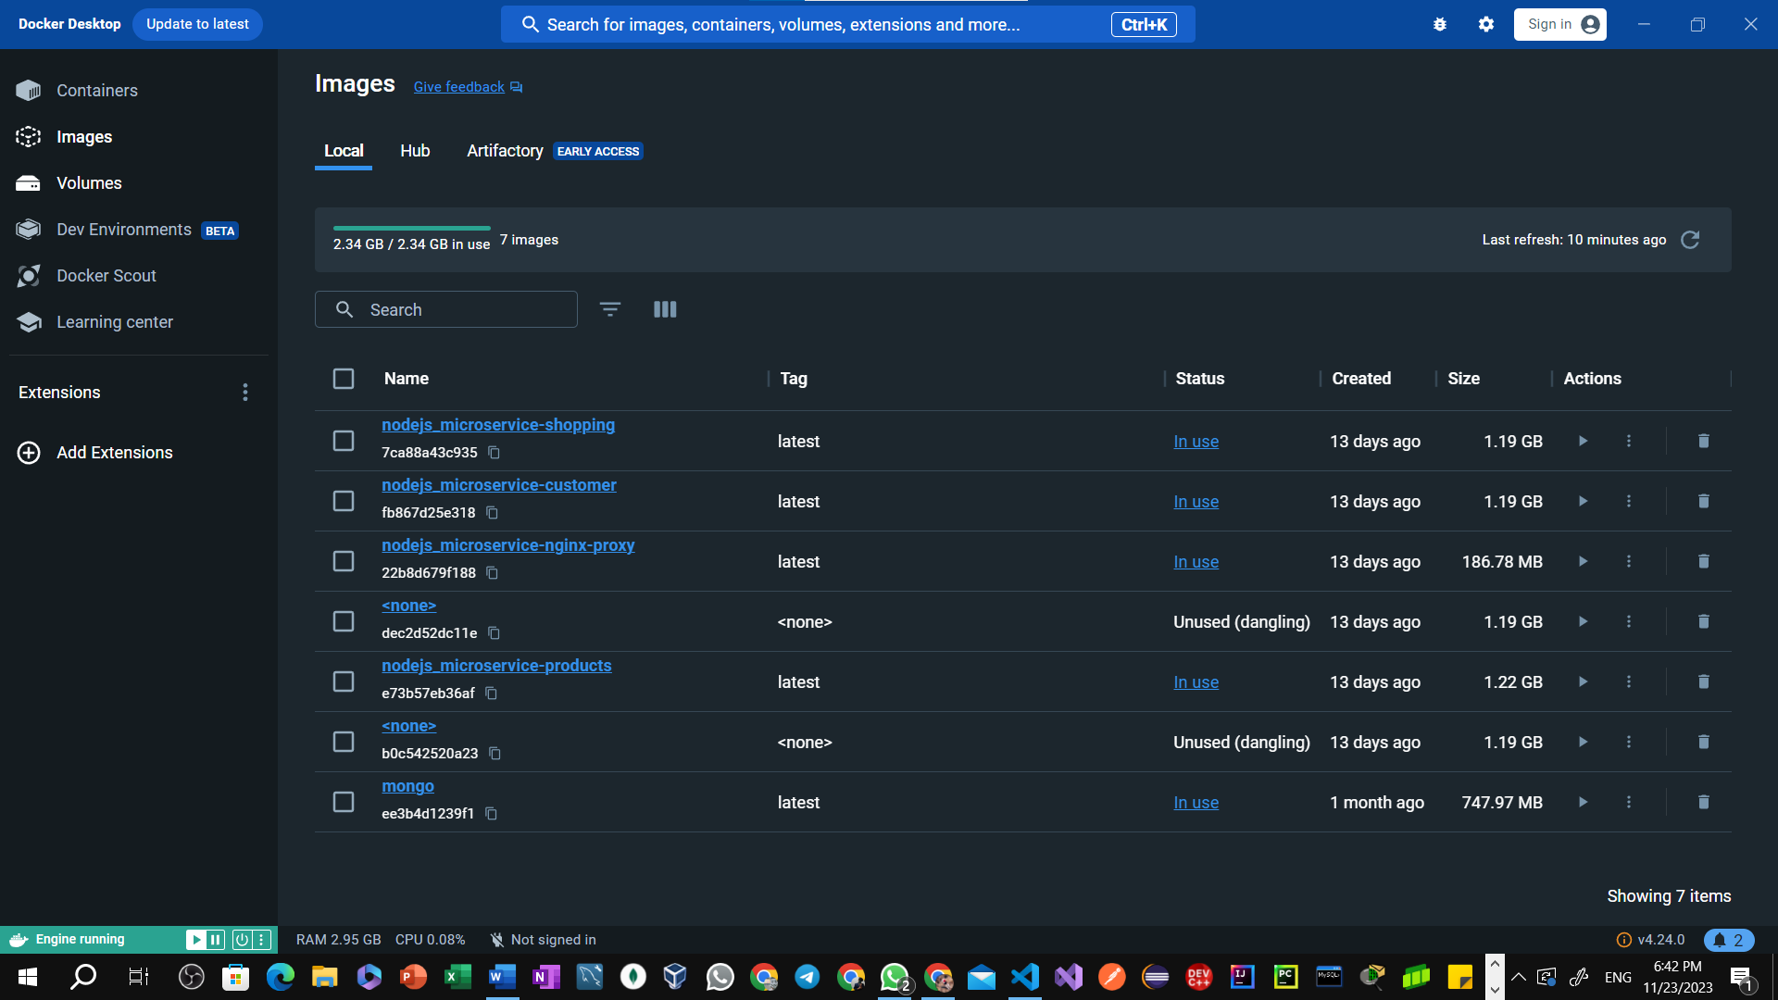

**Assignment 2 - Part 2: Deployment and Scaling (50 marks)**

**Cloud Platform Selection**

**1. Justify the choice of a specific cloud platform (e.g., AWS, Azure, Google Cloud) based on its suitability for the project.**

In the case of our "Grocery Online Shopping App," the justification of choosing of AWS (Amazon Web Services) based on its suitability for the project are as follows:

1. **Microservices Architecture Support:** AWS offers containerization services like Amazon ECS (Elastic Container Service) and Kubernetes-based Amazon EKS (Elastic Kubernetes Service), which are well-suited for deploying and managing microservices. These services provide the flexibility and scalability needed for a microservices-based architecture.
2. **Security and Compliance:** AWS places a strong emphasis on security, providing features like Identity and Access Management (IAM), encryption services, and compliance certifications. These features are crucial for handling sensitive customer data, especially in an online shopping app.

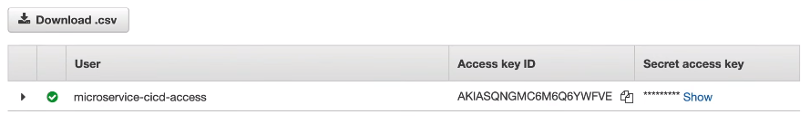

Creating user with help of IAM service in AWS

1. **Scalability and Elasticity:** AWS offers auto-scaling capabilities that allow our application to automatically adjust its capacity based on demand. This ensures that our online grocery shopping app can handle varying levels of user traffic efficiently, providing a seamless experience for customers.
2. **DevOps and CI/CD Support:** AWS integrates well with DevOps practices, providing tools like AWS CodePipeline and AWS CodeDeploy for continuous integration and deployment. This facilitates automated testing, building, and deployment of our microservices, streamlining the development and release process.

The choice of AWS for our "Grocery Online Shopping App" is justified by its comprehensive service offerings, strong support for microservices architecture, security features, scalability options, global presence, and integration with DevOps practices. It provides a robust and flexible foundation for building, deploying, and managing the various components of our online grocery shopping application.

**Container Orchestration**

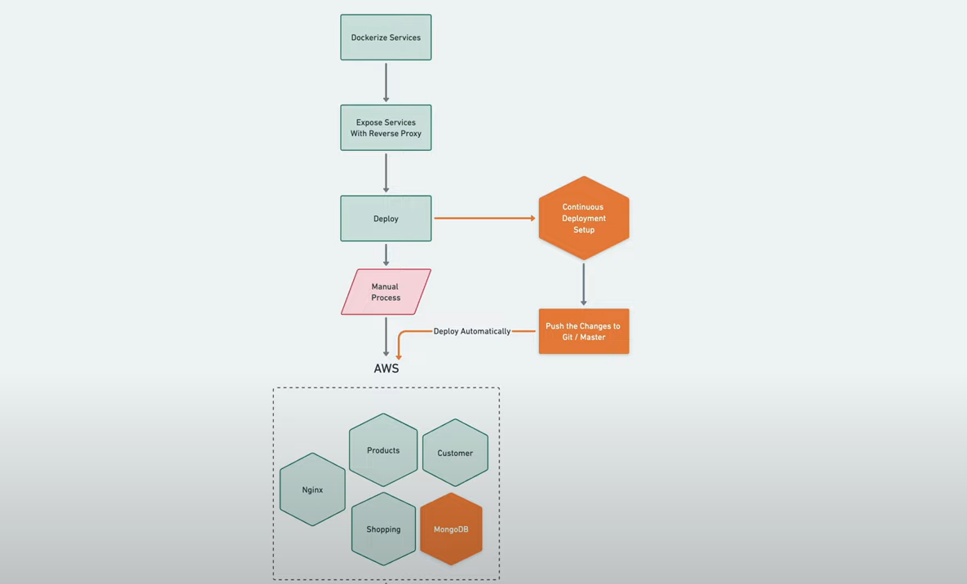**2. Utilize a container orchestration platform (e.g., Kubernetes) to manage and deploy the microservices.**

**Pre-requisites:**Kubernetes Cluster: Ensure we have access to a Kubernetes cluster, either locally using tools like Minikube.Minikube, a local Kubernetes solution, simplifies Kubernetes learning and development by requiring only Docker or a compatible container, making Kubernetes just a single command away with 'minikube start'.

Deployment Steps

**Step 1. Containerize Microservices**Ensure that each microservice (product, shopping, payments) is containerized using Docker. Each service should have its own Dockerfile. (already done)

**Step 2. Create Kubernetes Deployment Files**For each microservice, create Kubernetes Deployment YAML files. These files describe how Kubernetes should create and manage instances of our containers. (Need to be done)

**Manifest Creation:**

Deployment Manifest: # **customer-deployment.yaml**

apiVersion: apps/v1kind: Deploymentmetadata: name: customer-deploymentspec: replicas: 3 selector: matchLabels: app: customer template: metadata: labels: app: customer spec: containers: - name: products image: demo/ customer -service:latest ports: - containerPort: 8001 env: - name: DATABASE_URL value: mongodb://127.0.0.1:27017/msytt_customer

Deployment Manifest: **# products-deployment.yaml**

apiVersion: apps/v1kind: Deploymentmetadata: name: products-deploymentspec: replicas: 3 selector: matchLabels: app: products template: metadata: labels: app: products spec: containers: - name: products image: demo/products-service:latest ports: - containerPort: 8002 env: - name: DATABASE_URL value: mongodb://127.0.0.1:27017/msytt_products

Deployment Manifest: **# shopping-deployment.yaml**

apiVersion: apps/v1

kind: Deployment

metadata:

name: shopping-deployment

spec:

replicas: 3

selector:

matchLabels:

app: shopping

template:

metadata:

labels:

app: shopping

spec:

containers:

- name: shopping

image: demo/shopping-service:latest

ports:

- containerPort: 8003

env:

- name: DATABASE_URL

value: mongodb://127.0.0.1:27017/msytt_shopping

**Step 3. Create Kubernetes Services**Create Kubernetes Service YAML files for each microservice. Services allow communication between different microservices.

Service YAML: Defines how other services or external clients can access our microservices. This includes details like ports, protocols, and selectors.

Service Manifest: **# customer-service.yaml**

apiVersion: v1

kind: Service

metadata:

name: customer-service

spec:

selector:

app: products

ports:

- protocol: TCP

port: 80

targetPort: 8001

Service Manifest: **# products-service.yaml**

apiVersion: v1

kind: Service

metadata:

name: products-service

spec:

selector:

app: products

ports:

- protocol: TCP

port: 80

targetPort: 8002

Service Manifest: **# shopping-service.yaml**

apiVersion: v1

kind: Service

metadata:

name: shopping-service

spec:

selector:

app: products

ports:

- protocol: TCP

port: 80

targetPort: 8003

**Step 4. Apply Deployments and Services**

Use kubectl to apply the Deployment and Service YAML files for each microservice:

kubectl apply -f <microservice-deployment.yaml>

kubectl apply -f <microservice-service.yaml>

**Step 5. Verify Deployments and Check if our microservices are running:**

kubectl get pods # Check podskubectl get services # Check serviceskubectl describe pod <pod-name> # Detailed info about a pod

**3. Describe how container orchestration simplifies deployment, scaling, and management.**

In the context of our "Grocery Online Shopping App" project, container orchestration plays a crucial role in simplifying deployment, scaling, and management of the microservices architecture. Here's how container orchestration addresses these aspects:

Container orchestration simplifies deployment, scaling, and management by automating the processes of deploying and managing containers at scale. It abstracts complexities, streamlines resource allocation, automates scaling based on demand, and provides centralized management, making it easier to maintain, update, and scale applications in a containerized environment.

**Deployment Simplification:** With the transition to a microservices architecture, our application is likely composed of multiple services running in separate containers. Container orchestration tools, such as Kubernetes or Docker Swarm, simplify the deployment process by automating the distribution of containerized microservices across a cluster of machines.

**Scaling:** If the load on our "Grocery Online Shopping App" increases, we can easily scale specific microservices or the entire application. Kubernetes, for example, supports horizontal scaling, where we can dynamically adjust the number of running instances of a microservice based on factors like CPU usage or incoming requests.

**Management Efficiency:** Container orchestration tools provide centralized management and monitoring capabilities, allowing we to oversee the health and performance of our microservices.

**Resource Optimization:** Container orchestration optimizes resource utilization by efficiently distributing microservices across the available infrastructure. Containers are isolated from each other, preventing interference and ensuring that each microservice runs in its own environment.

**Load Balancing:** Container orchestration tools often include built-in load balancing capabilities, distributing incoming traffic across multiple instances of a microservice. This ensures even distribution of requests, preventing any single microservice instance from becoming a bottleneck.

**Deployment Process**

**4. Provide scripts or configurations for deploying the microservices on the chosen cloud platform.**

AWS ECS Deployment

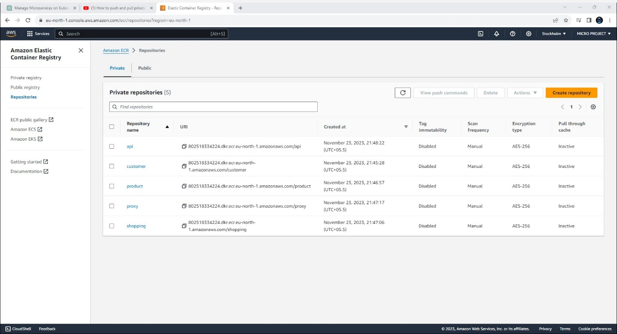Step 1: Push the images from your local machine to Amazon ECR (Elastic Container Registry):

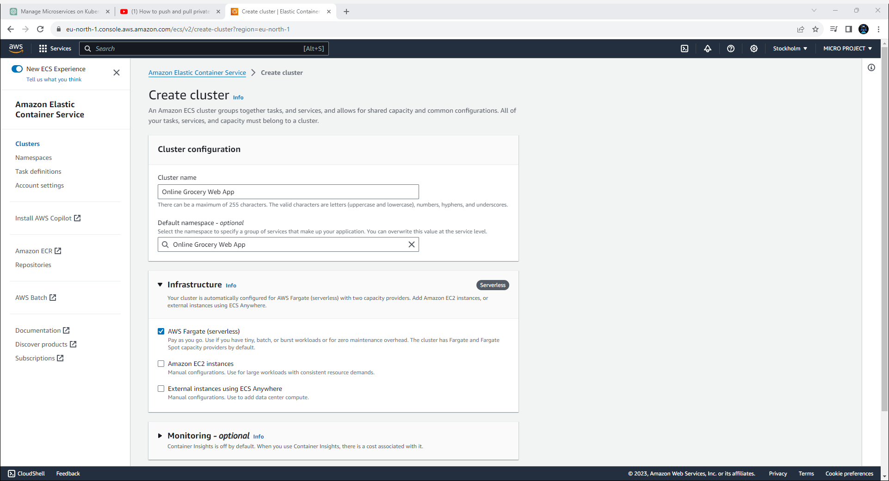Step 2: Create a cluster using Amazon ECS (Elastic Container Service): In this case, I opted for AWS Fargate over Amazon EC2 as it simplifies various complexities and decision-making, offering a faster and more straightforward approach. Additionally, I enabled monitoring during the cluster creation process, eliminating the need for a separate monitoring setup.

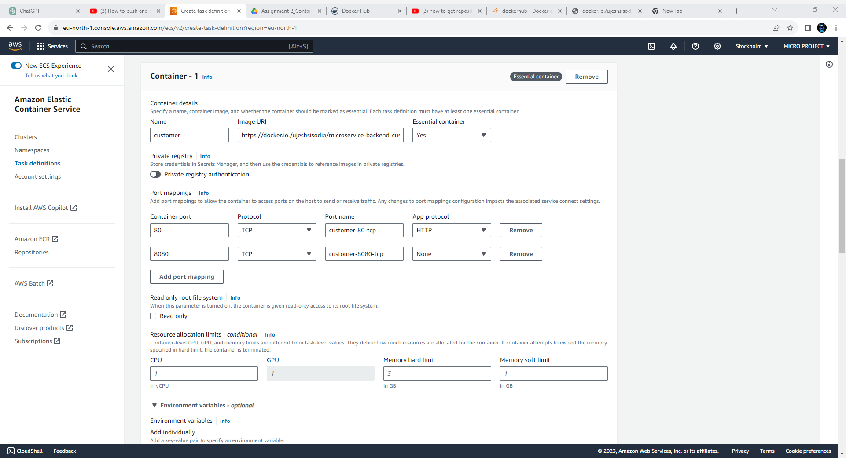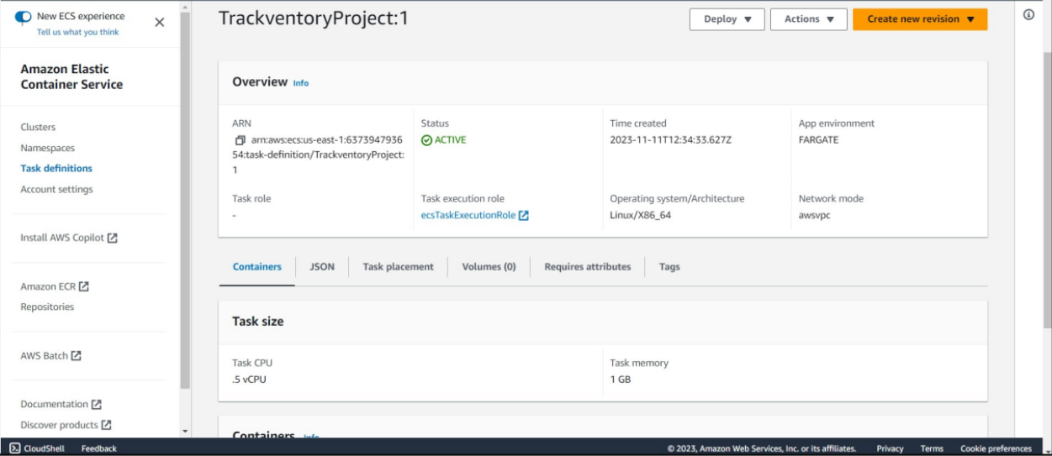Step3: Task- A task is the instantiation of a task definition within a cluster. After you create a task definition for your application within Amazon ECS, you can specify thenumber of tasks to run on your cluster. An Amazon ECS service runs and maintainsyour desired number of tasks simultaneously in an Amazon ECS cluster. After creating a task, we had to wait a couple of minutes for its status to turn active.

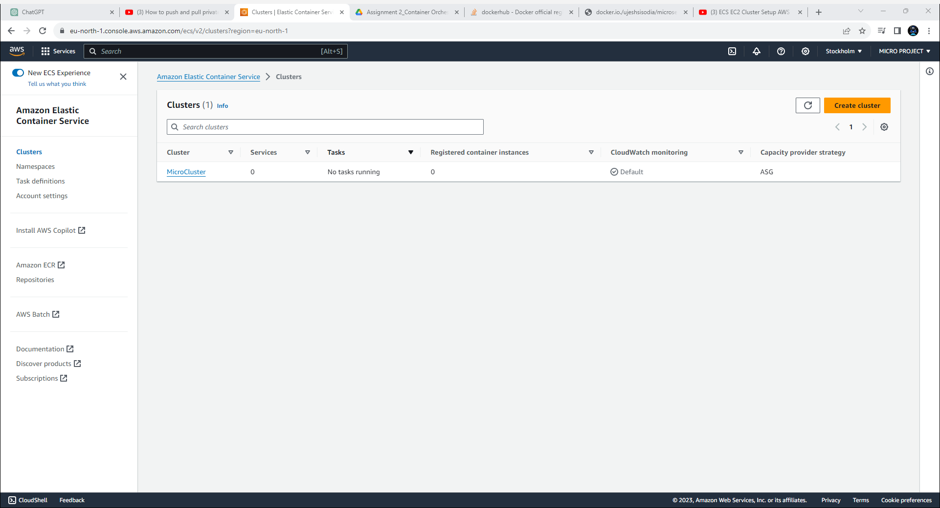Step 4: To create the containers

AWS EKS Deployment

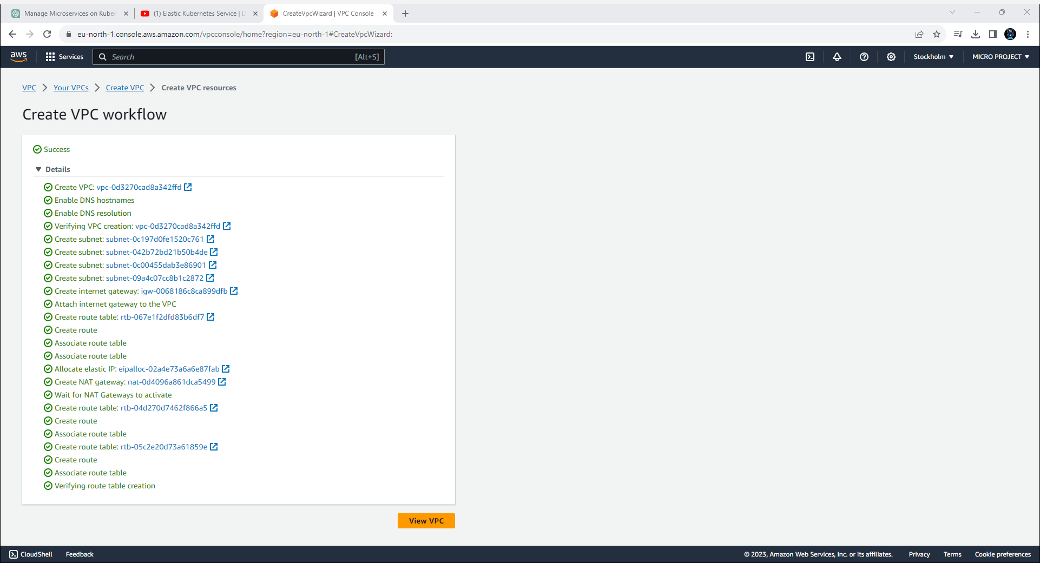

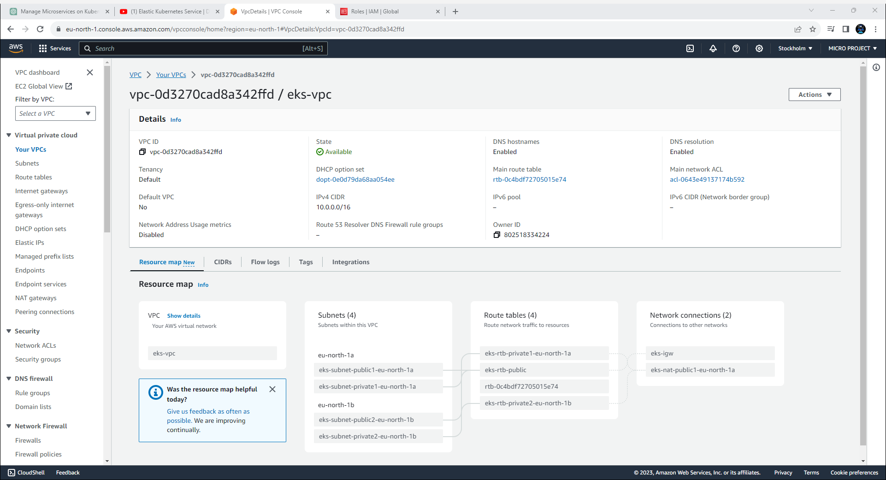

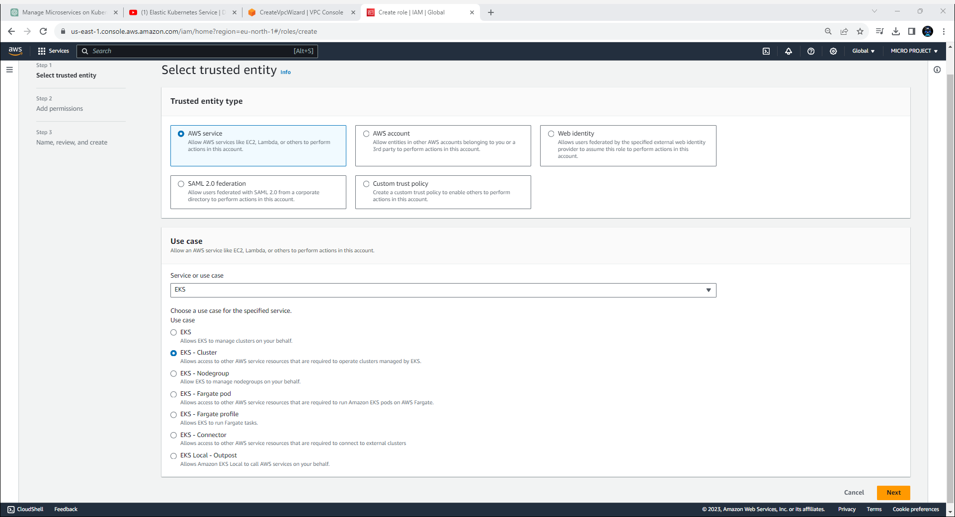

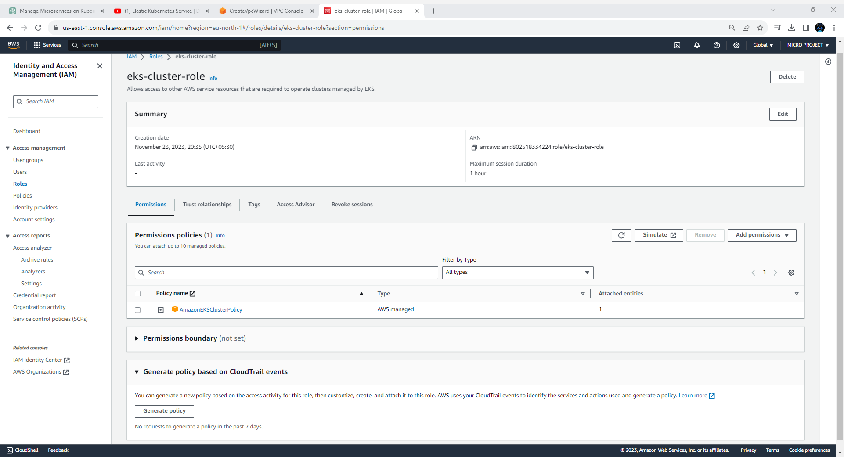

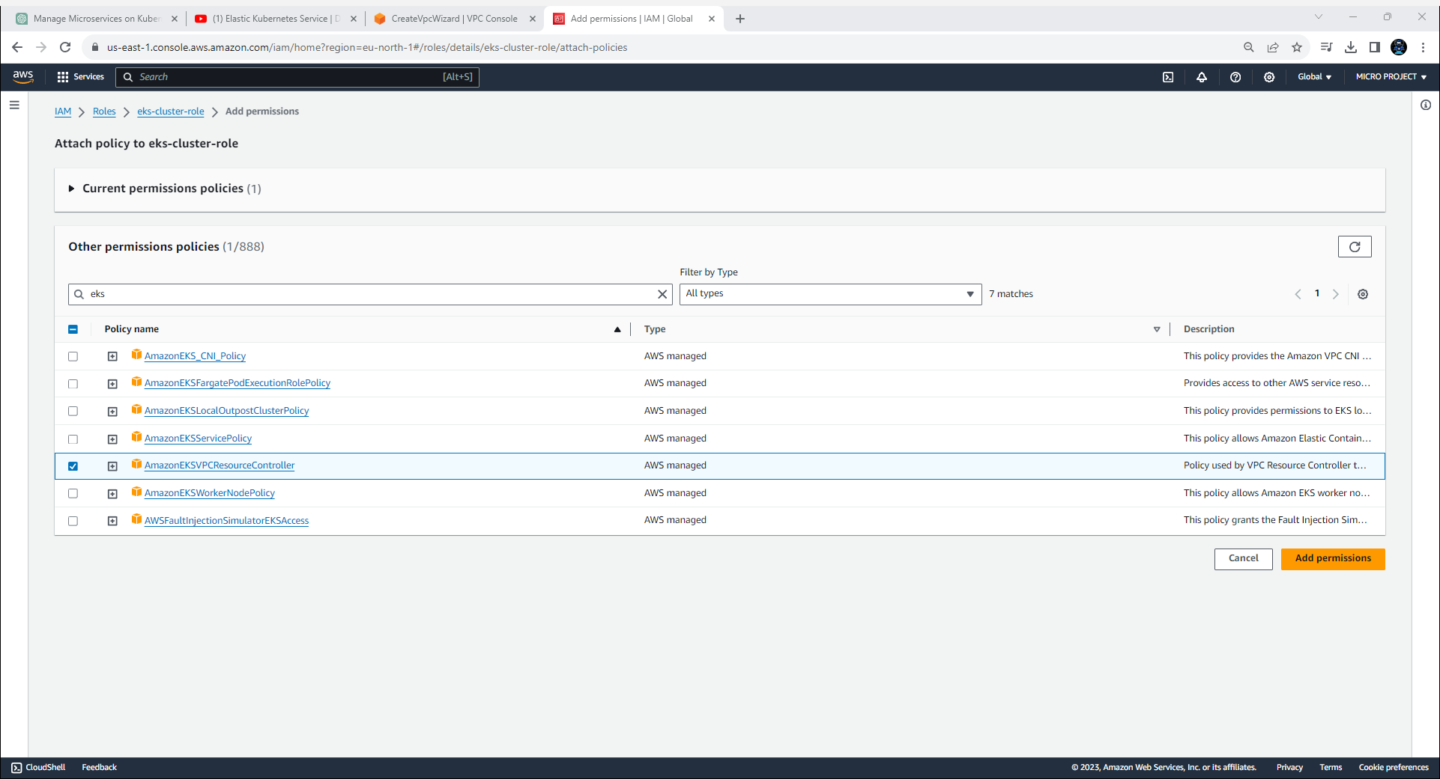

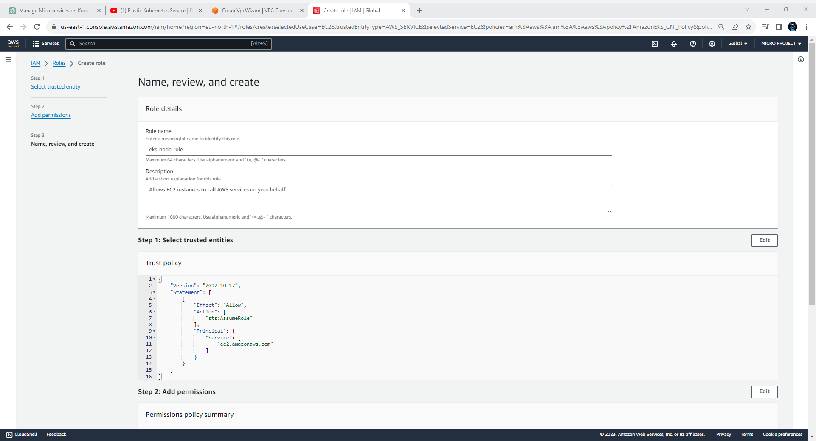

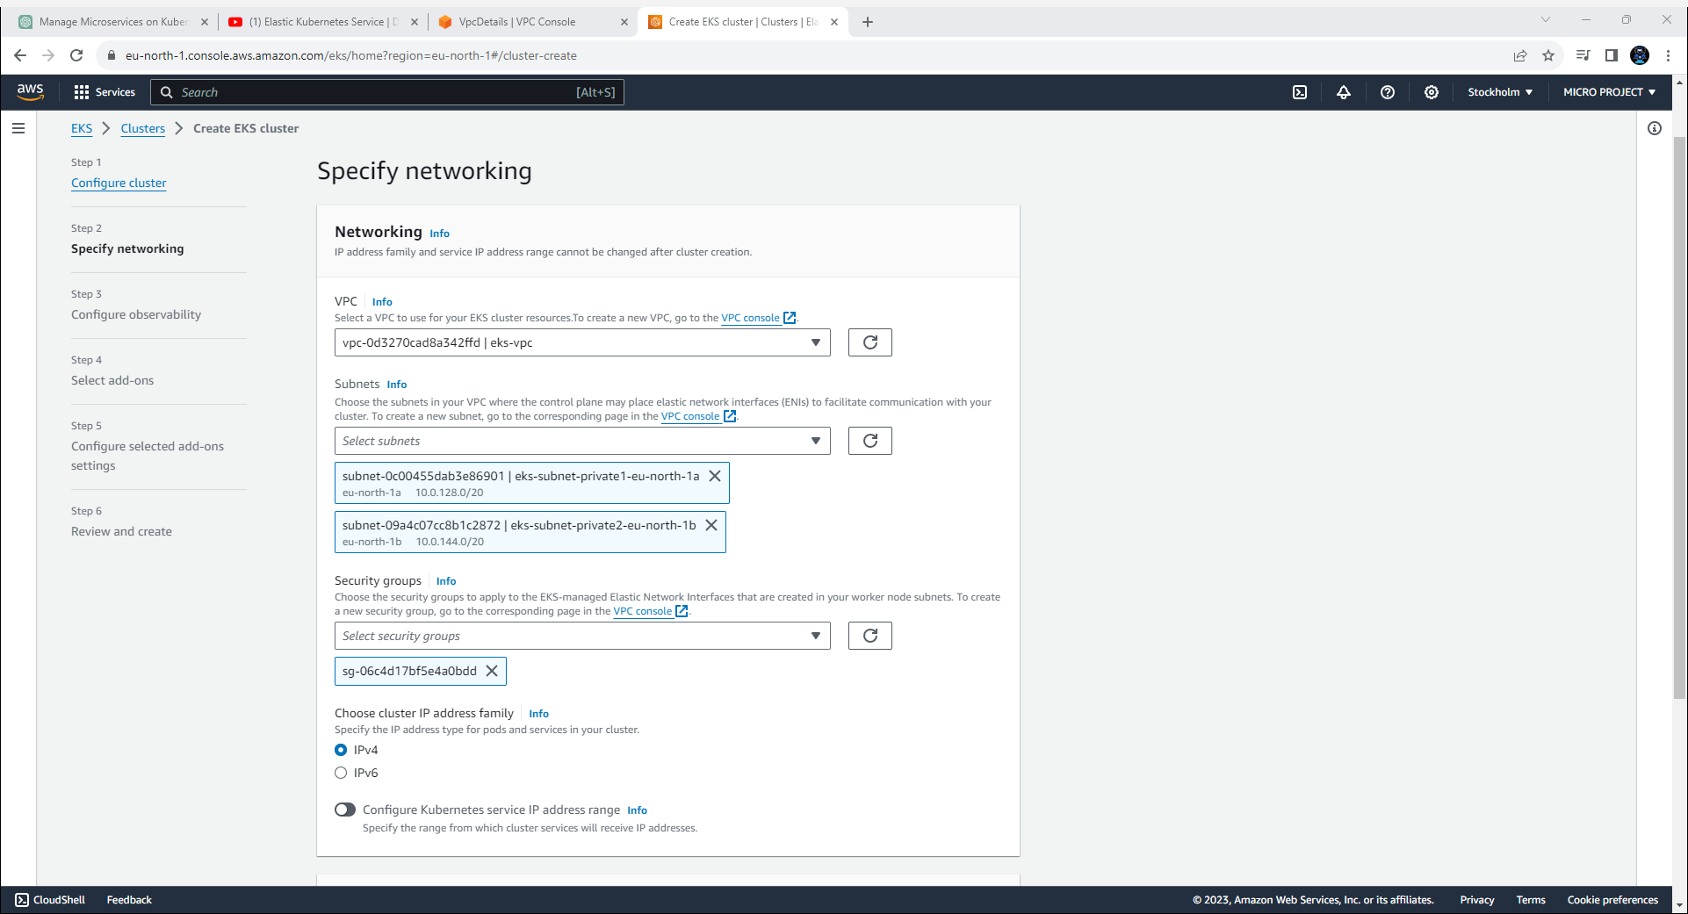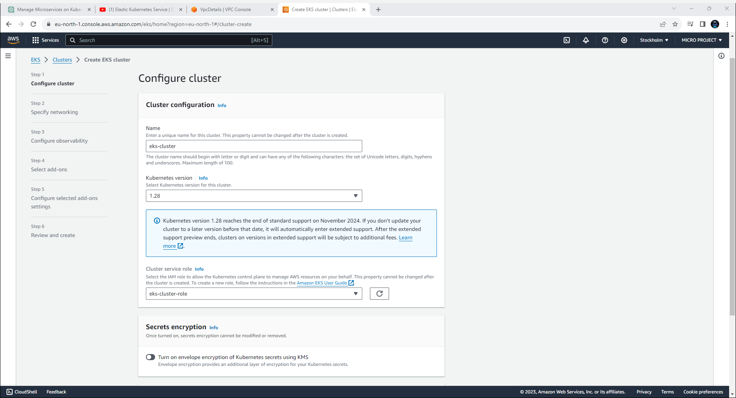

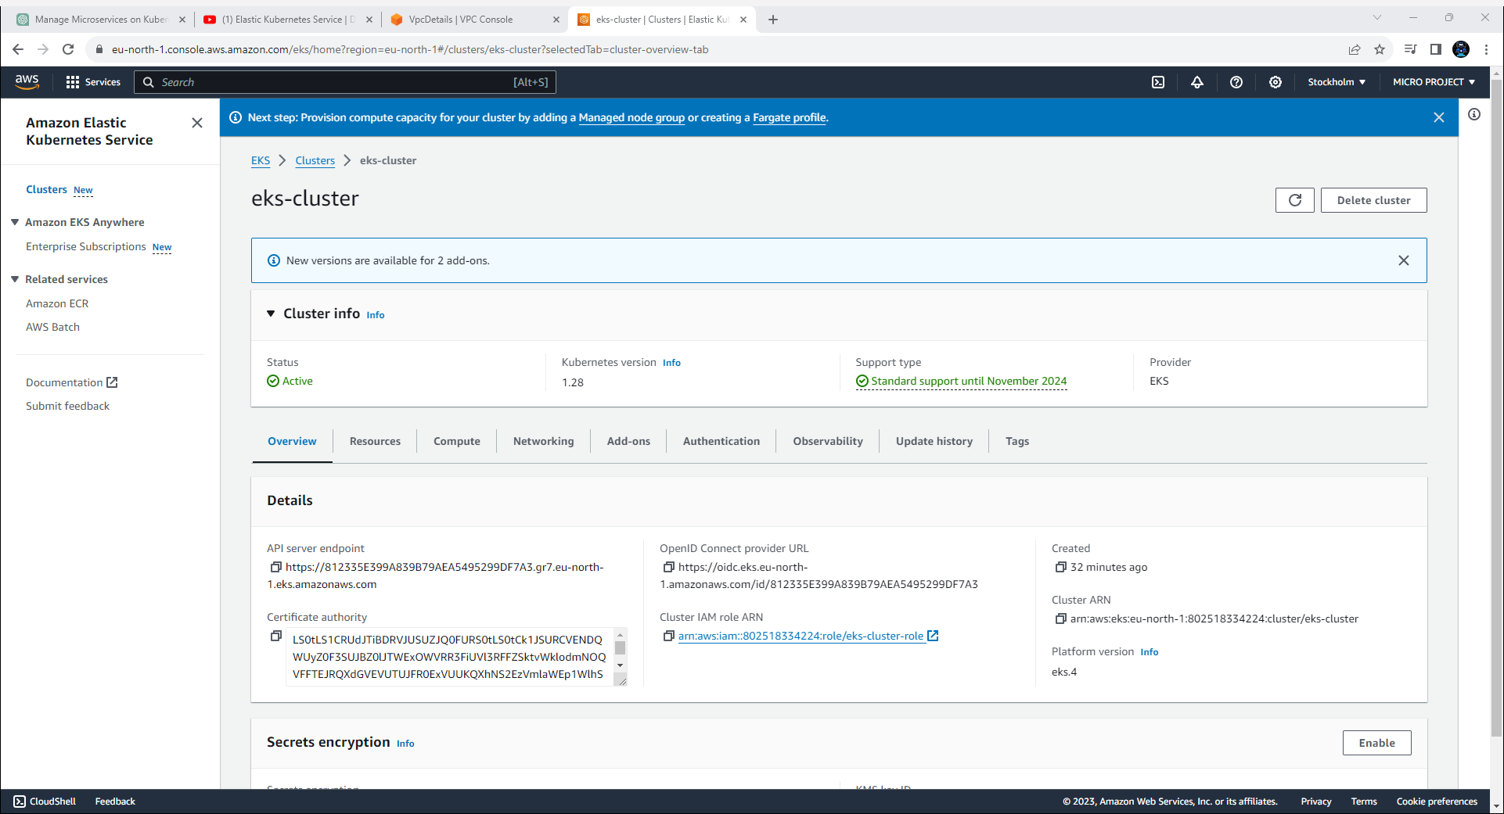

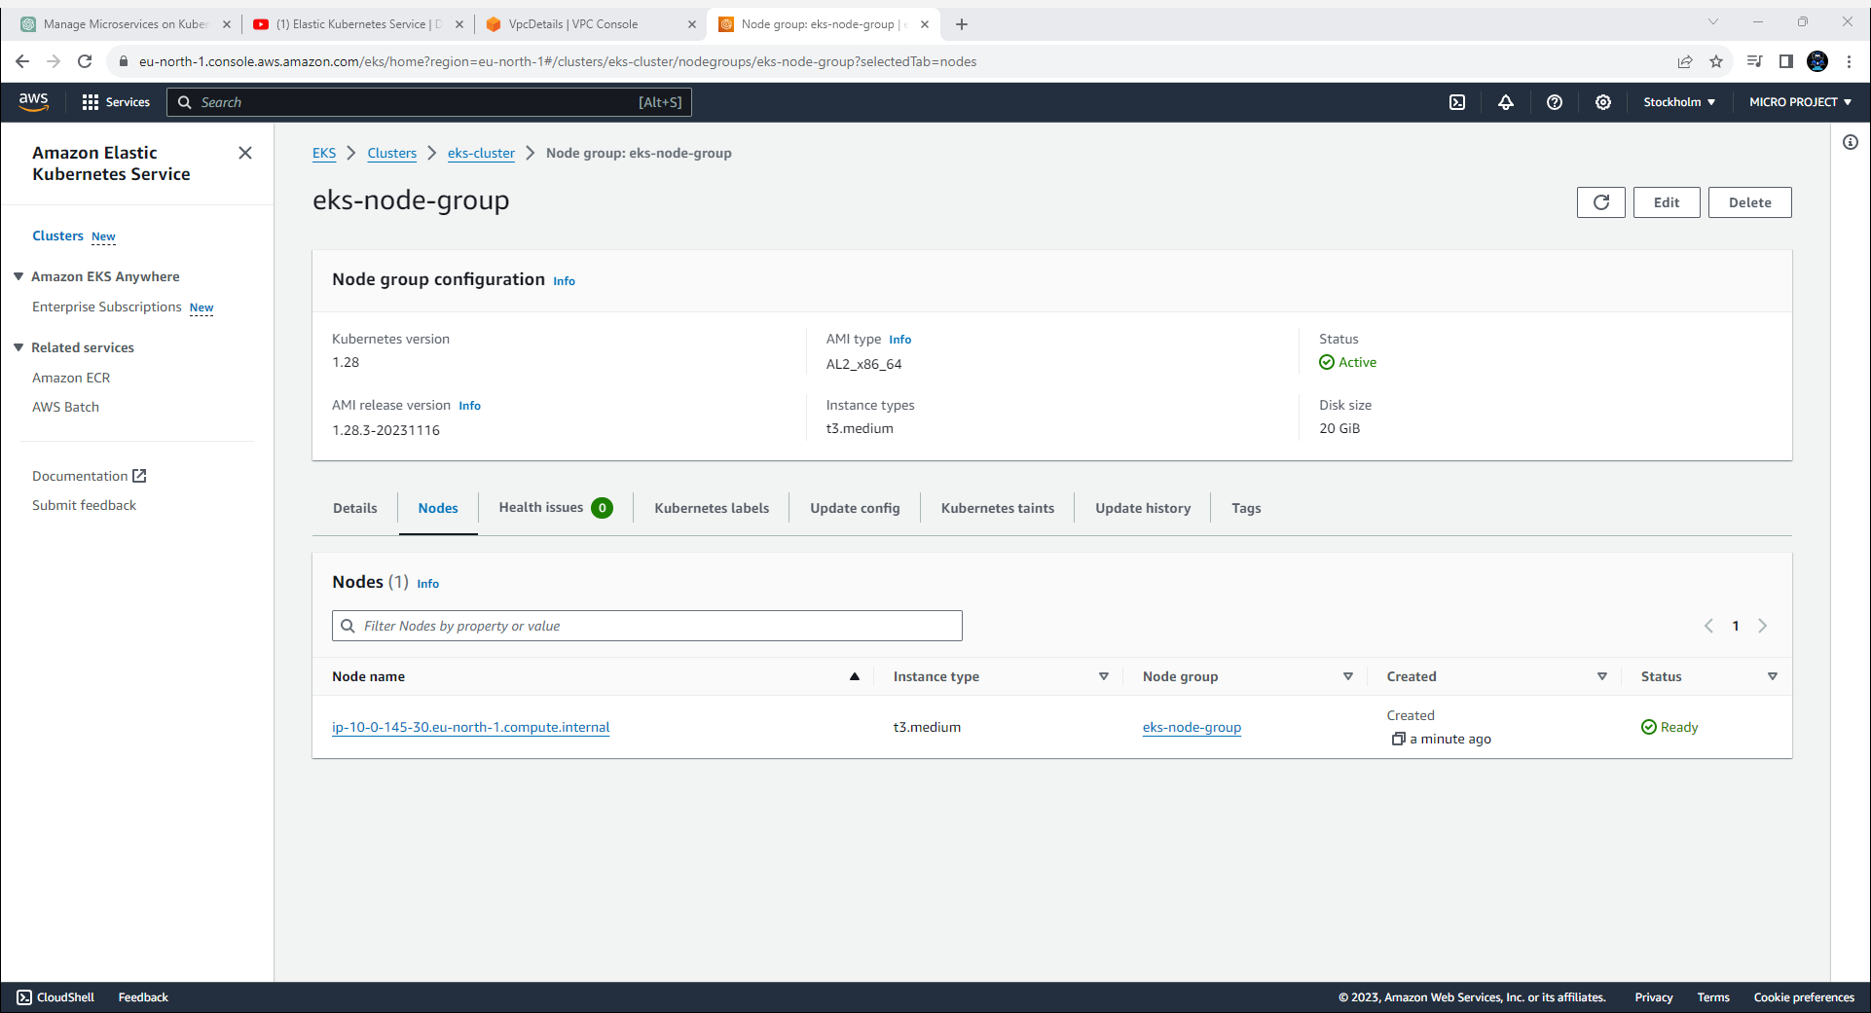

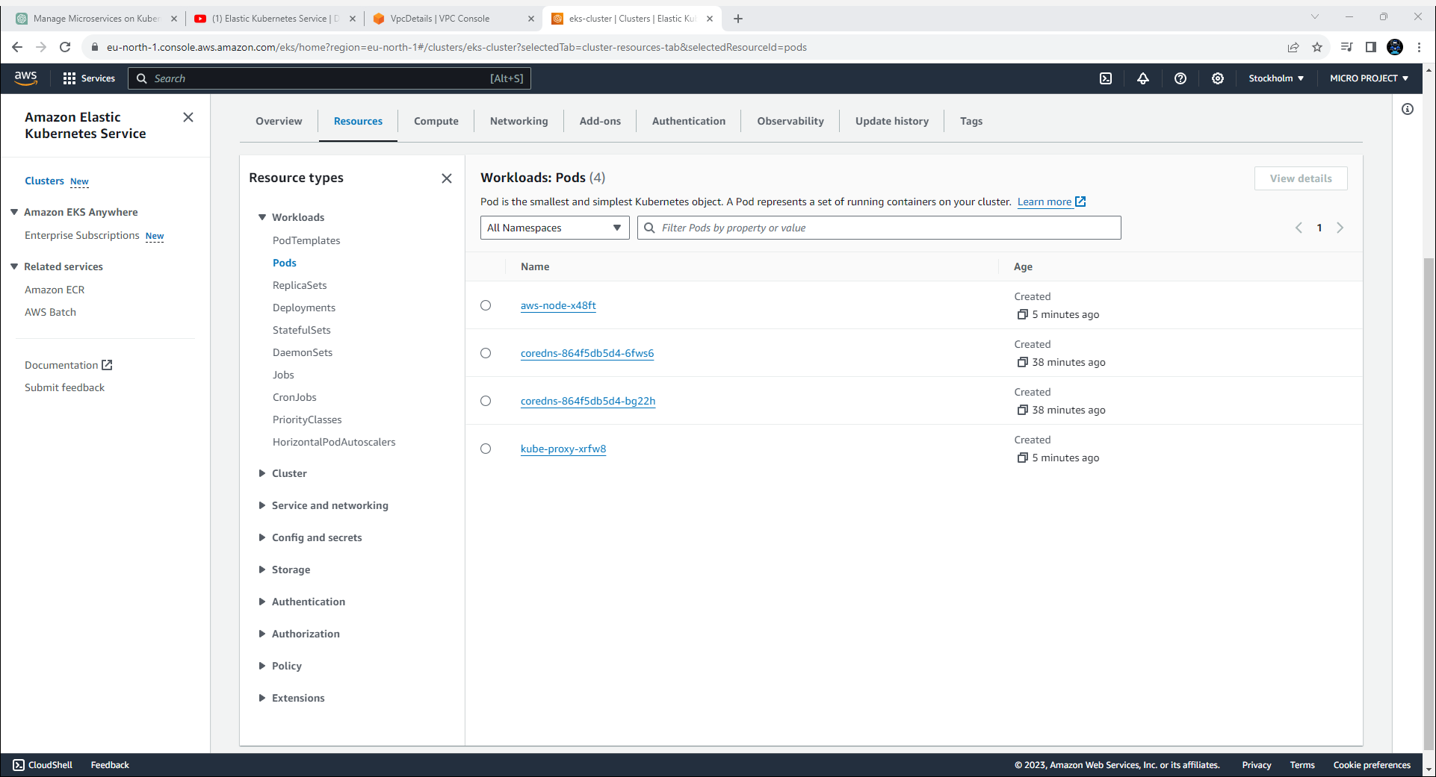

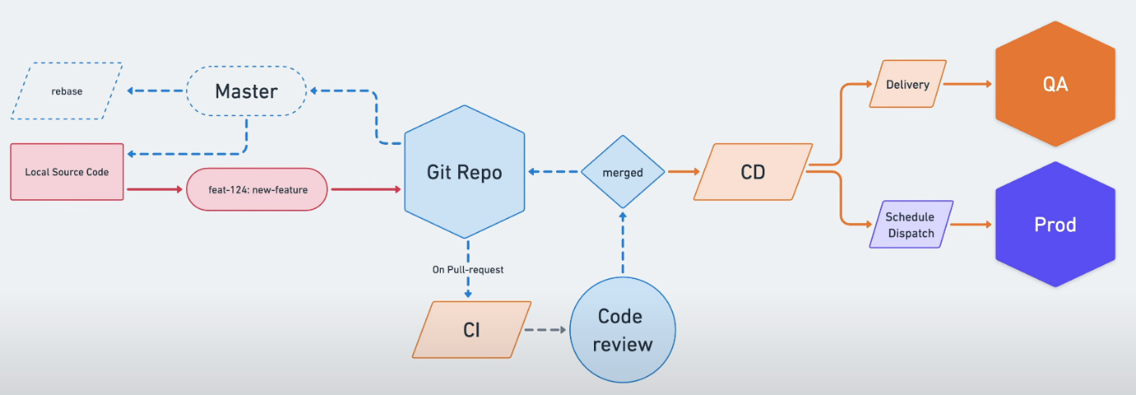**5. Demonstrate the ability to deploy the application in a cloud environment consistently.**

First of all, the Local Source code is pointed to Master. And when we working in the new feature then we check out to the new branch and that specific branch is going to work on whatever the changes we are going to do. Once it is done then we will push the source code to git repository. Afterwards once we have pushed the changes then we are going to pull the request.

And once we have pulled the request then there is a kind of settings that is Continuous Integration. This setting will take care all the test cases that what we are adding to new feature.

After passing all the test cases we can raise a kind of Code Review request. If the code review request is approved by other team member, then we can merge the source code to the repository. As soon as we have merged the source code it will run the Continuous Deployment pipeline.

It depends upon which pipeline that which pipeline is going to accommodate by default and depends on that it will automatically to the QA environment or maybe production environment.

Demonstration:

1. 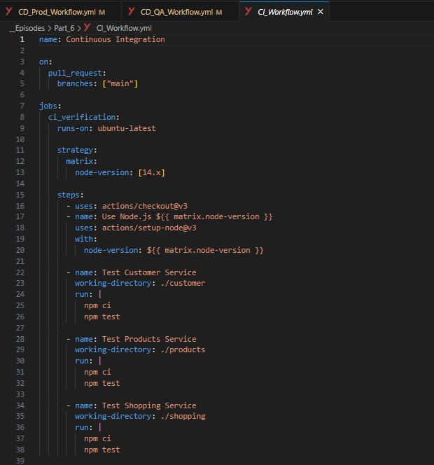**CI_Workflow.yml:** this file contains all the configuration for the Continuous Improvement.
2. 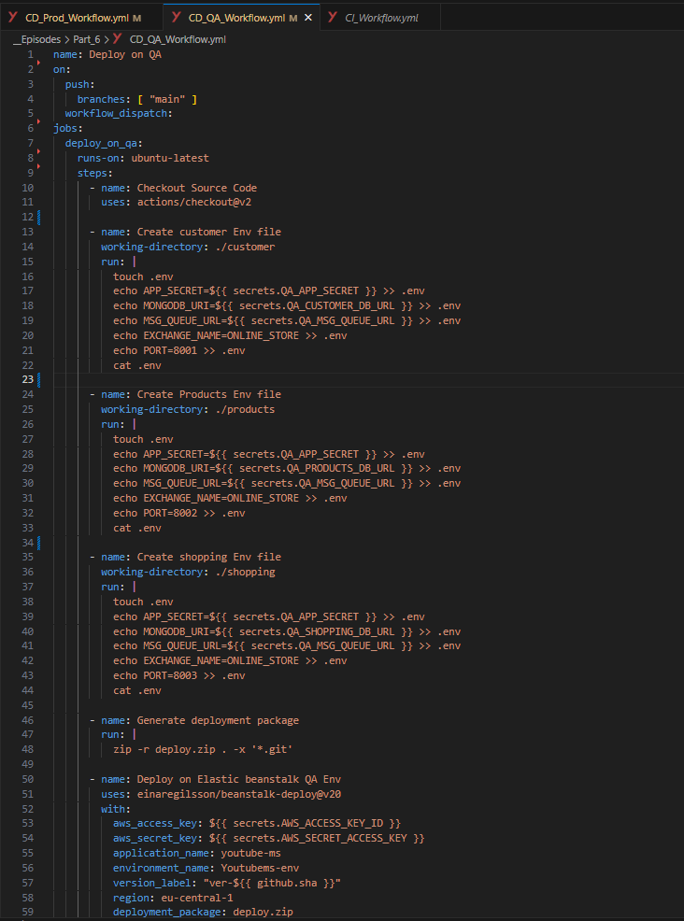**CD_QA_Workflow.yml:** this file contains all the configuration for theContinuous Deployment.
3. 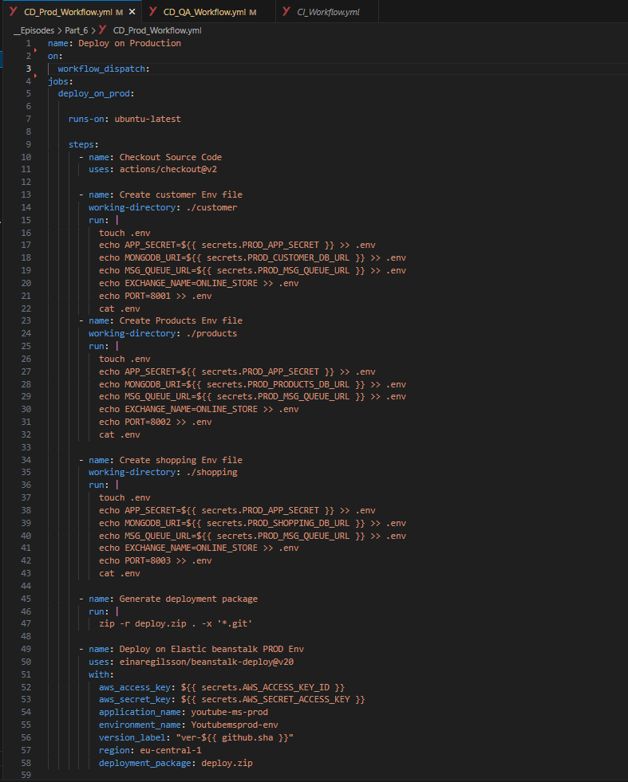**CD_Prod_Workflow.yml:** this file contains all the configuration for theContinuous Deployment.
4. 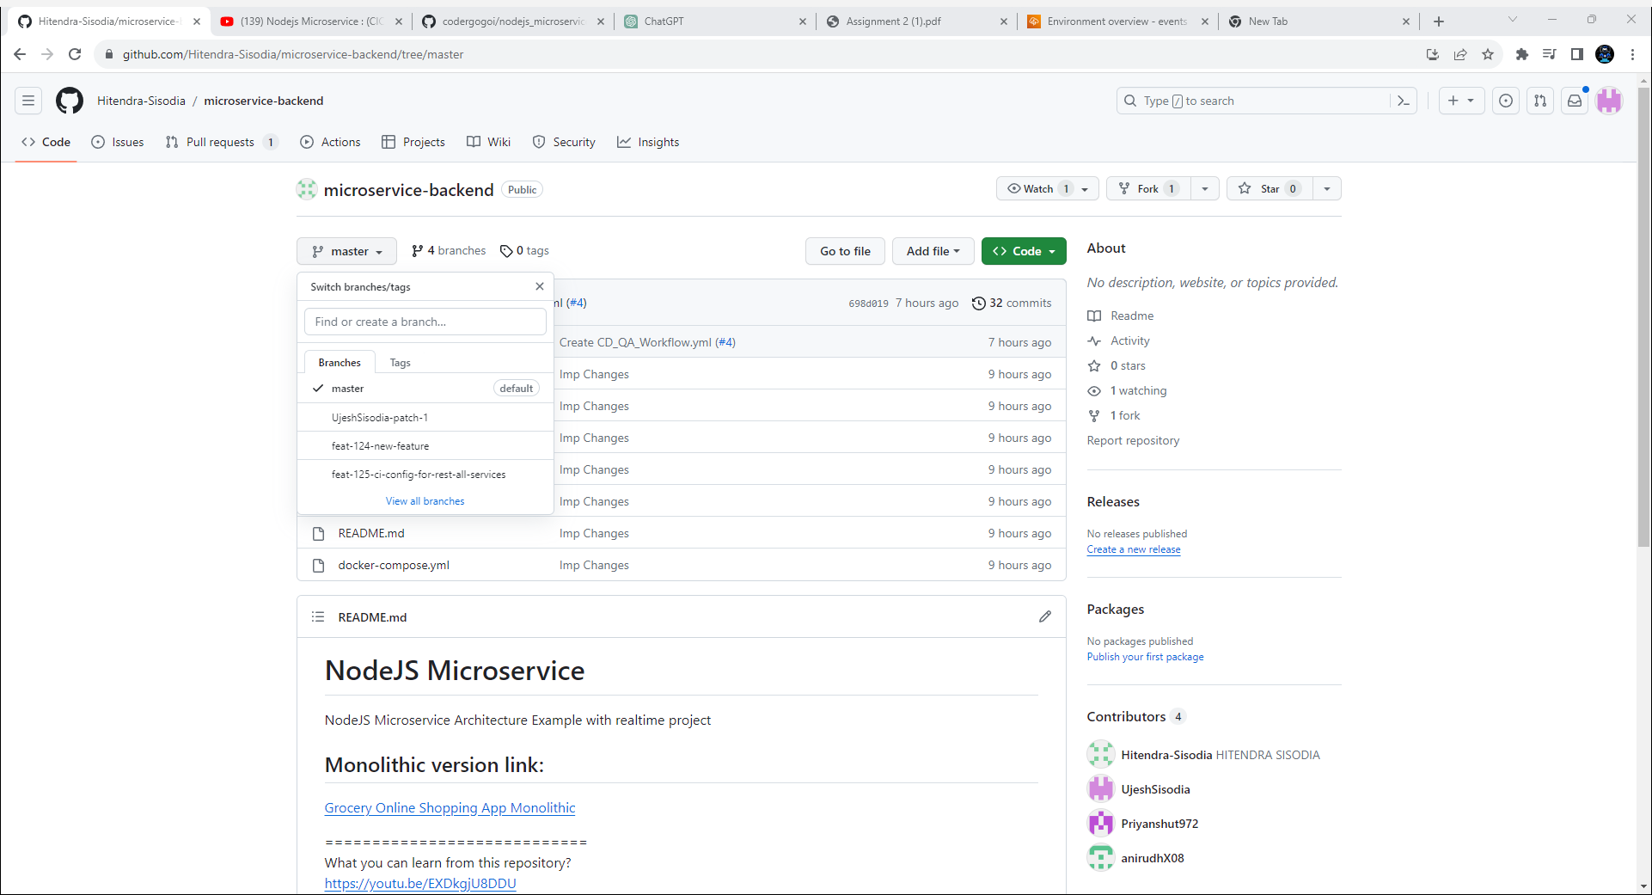We have default branch i.e., master. We have created new branch feature i.e., feat-124-new-feature and feat-125-ci-config-for-all-services.
5. 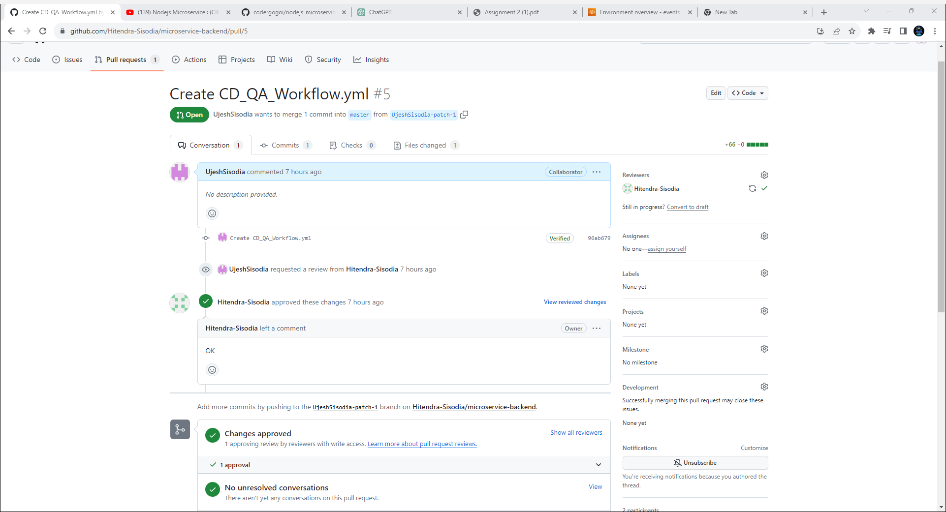The changes which we have made are reviewed by our team member.
6. 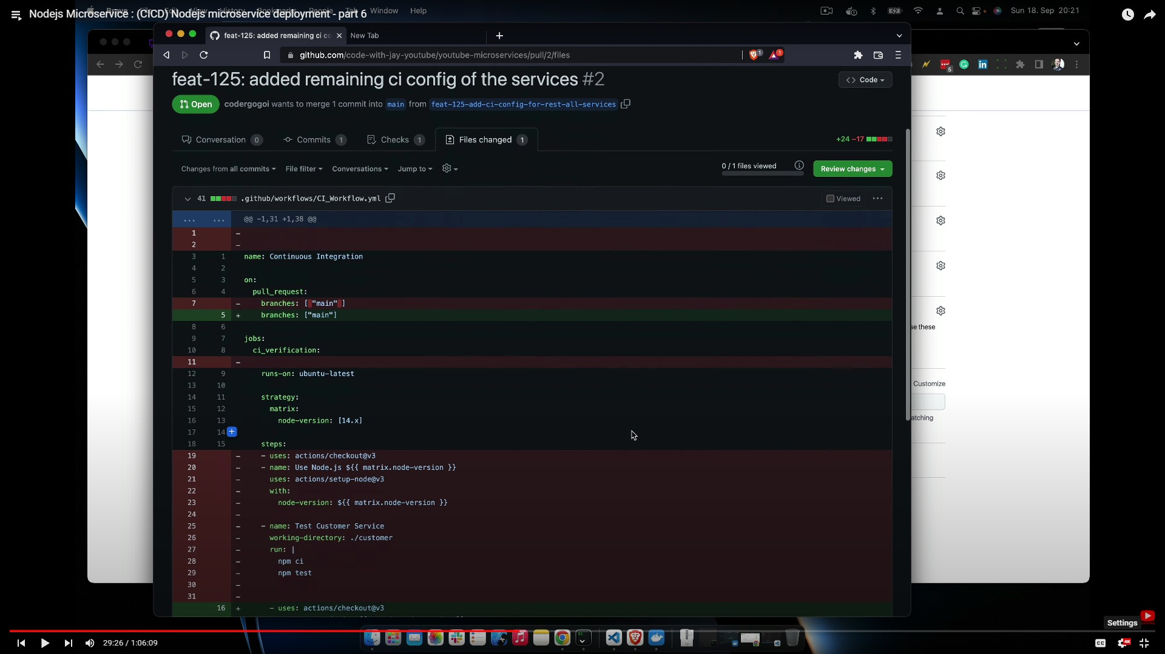The changes which I made was adding configuration files for each microservice.
7. These are the Continuous integration changes which we have made in two new branch which we created.

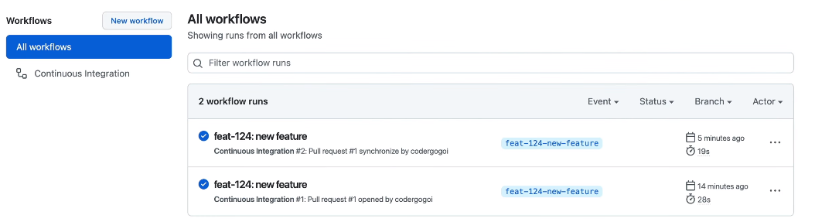

1. 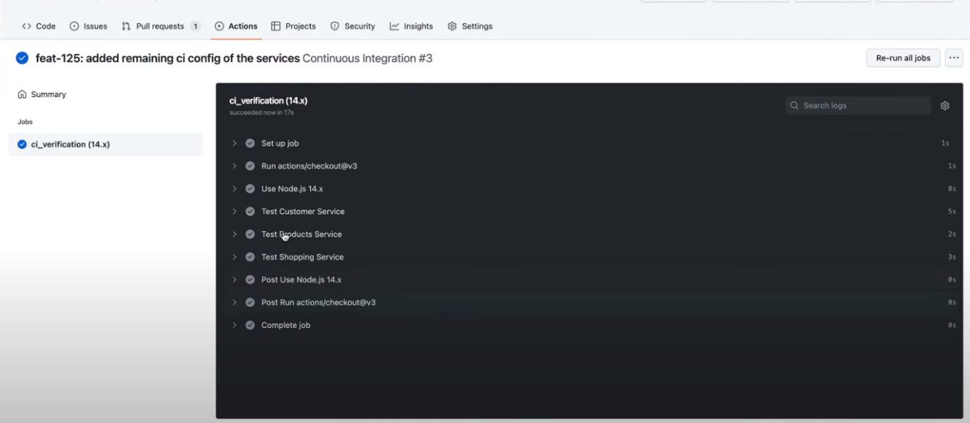The verification are as follows.
2. 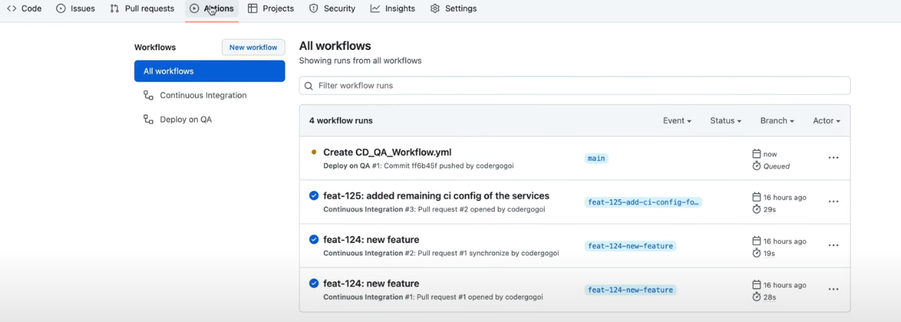Creating Continuous Deployment Workflow.
3. 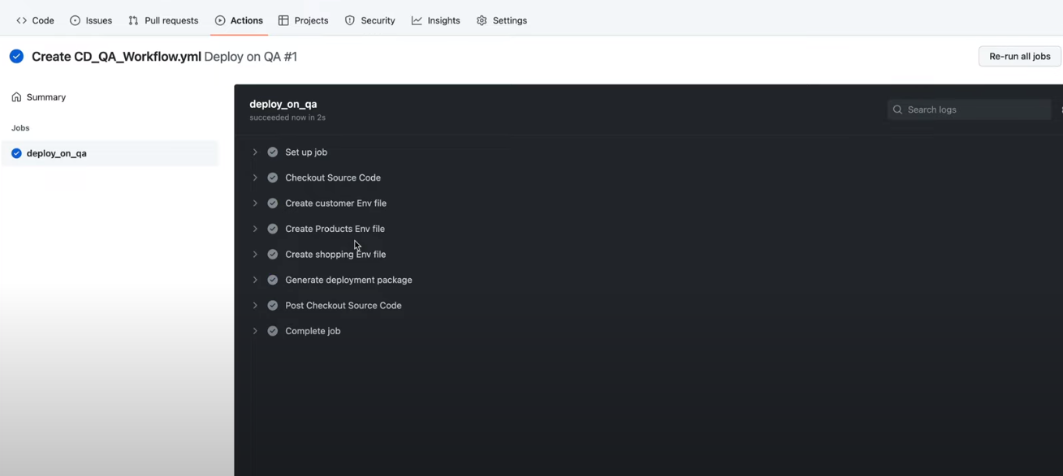Now we will verify the Continuous Deployment
4. 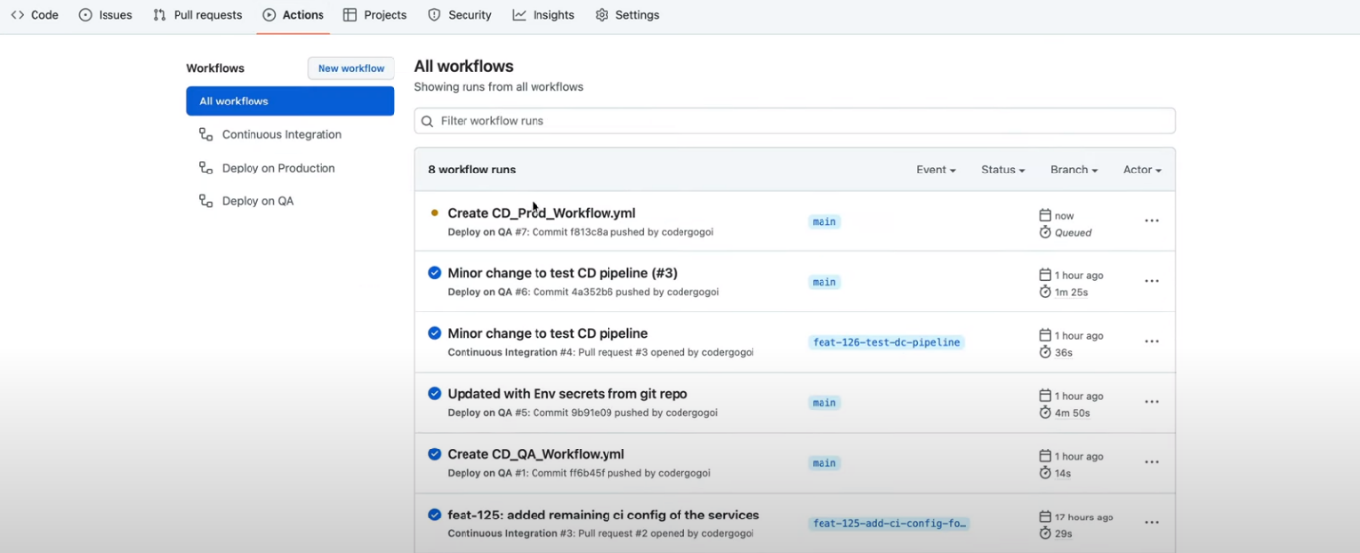Updating the Continuous Deployment production environment in the workflow.
5. 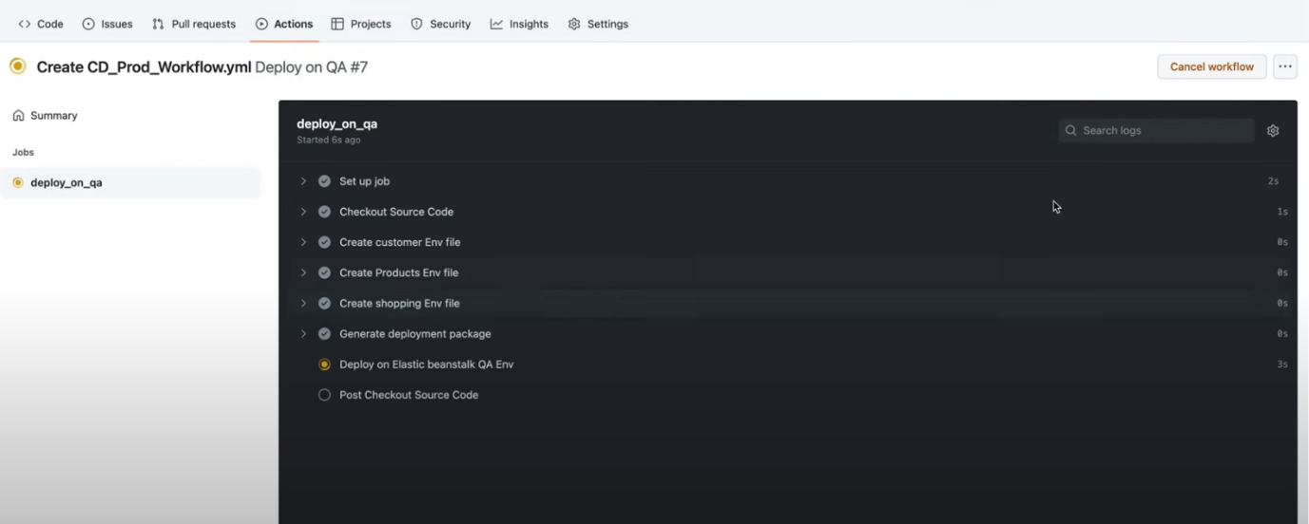And verification are as follows

**Scaling and Load Balancing**

6. Implementing automatic scaling mechanisms for microservices based on resource usage is essential for ensuring optimal performance and resource utilization. Here's a general approach to implementing automatic scaling, assuming we're working with a container orchestration platform like Kubernetes:

Monitoring Resource Metrics: Set up monitoring for key resource metrics such as CPU utilization, memory usage, and network traffic. Tools like Prometheus and Grafana can be integrated into our Kubernetes cluster to collect and visualize these metrics.

Define Scaling Policies: Define scaling policies based on the monitored metrics. For example, we might decide to scale up the number of instances when CPU utilization exceeds a certain threshold or scale down when it falls below another threshold. Similar policies can be defined for memory usage and other relevant metrics.

Horizontal Pod Autoscaler (HPA): In Kubernetes, use the Horizontal Pod Autoscaler (HPA) to automatically adjust the number of replicas (instances) of a microservice based on observed metrics. Here's an example YAML configuration for an HPA that scales based on CPU utilization.

**This HPA configuration specifies scaling behaviour based on CPU utilization, maintaining a minimum of 2 replicas and scaling up to a maximum of 10 replicas.**

**Customer HPA**

apiVersion: autoscaling/v2beta2

kind: HorizontalPodAutoscaler

metadata:

name: customer-service-hpa

spec:

scaleTargetRef:

apiVersion: apps/v1

kind: Deployment

name: customer-service-deployment

minReplicas: 2

maxReplicas: 10

metrics:

- type: Resource

resource:

name: cpu

targetAverageUtilization: 50

In this example, the HPA targets a deployment named my-microservice and scales the number of replicas to maintain an average CPU utilization of 50%.

**Products HPA**

apiVersion: autoscaling/v2beta2

kind: HorizontalPodAutoscaler

metadata:

name: products-service-hpa

spec:

scaleTargetRef:

apiVersion: apps/v1

kind: Deployment

name: products-service-deployment

minReplicas: 2

maxReplicas: 10

metrics:

- type: Resource

resource:

name: cpu

targetAverageUtilization: 50

**Shopping HPA**

apiVersion: autoscaling/v2beta2

kind: HorizontalPodAutoscaler

metadata:

name: shopping-service-hpa

spec:

scaleTargetRef:

apiVersion: apps/v1

kind: Deployment

name: shopping-service-deployment

minReplicas: 2

maxReplicas: 10

metrics:

- type: Resource

resource:

name: cpu

targetAverageUtilization: 50

Vertical Pod Autoscaler (VPA): Consider using the Vertical Pod Autoscaler (VPA) if our microservices have variable resource requirements. VPA adjusts the resource requests and limits for containers based on historical usage patterns.

Customer VPA

apiVersion: autoscaling.k8s.io/v1

kind: VerticalPodAutoscaler

metadata:

name: customer-service-vpa

spec:

targetRef:

apiVersion: "apps/v1"

kind: "Deployment"

name: "customer-service-deployment"

updatePolicy:

updateMode: "Auto"

Products VPA

apiVersion: autoscaling.k8s.io/v1

kind: VerticalPodAutoscaler

metadata:

name: products-service-vpa

spec:

targetRef:

apiVersion: "apps/v1"

kind: "Deployment"

name: "customer-service-deployment"

updatePolicy:

updateMode: "Auto"

Shopping VPA

apiVersion: autoscaling.k8s.io/v1

kind: VerticalPodAutoscaler

metadata:

name: shopping-service-vpa

spec:

targetRef:

apiVersion: "apps/v1"

kind: "Deployment"

name: "customer-service-deployment"

updatePolicy:

updateMode: "Auto"

Cluster Autoscaler: For automatic scaling of nodes in our Kubernetes cluster based on overall resource demand, use the Cluster Autoscaler. This ensures that there are enough nodes to accommodate the scaling of individual microservices.

Prometheus Alert Manager: Set up alerts based on resource metrics using Prometheus Alert Manager. Define alert rules that trigger notifications when resource usage surpasses defined thresholds. These alerts can be used for both manual intervention and triggering automatic scaling.

Integration with Cloud Provider Auto Scaling: If our microservices run on a cloud platform (e.g., AWS, Google Cloud, Azure), leverage the cloud provider's auto-scaling features. For example, AWS Auto Scaling Groups can automatically adjust the number of EC2 instances based on predefined policies.

Continuous Monitoring and Tuning: Regularly review and adjust our scaling policies based on the changing characteristics of our microservices. Continuous monitoring helps identify trends and patterns that might require adjustments to scaling thresholds.

**Load Testing: Conduct load testing to simulate different levels of user traffic and observe how our scaling mechanisms respond. This helps ensure that our system can handle varying workloads effectively.**

**Logging and Auditing: Implement logging and auditing mechanisms to capture scaling events and changes in resource usage. This information is valuable for post-event analysis and troubleshooting.**

7. Following are the ways for achieving load balancing:

1. **Container Orchestration Platforms:** Container orchestration platforms, such as Kubernetes and Docker Swarm, provide built-in support for load balancing. These platforms manage the deployment, scaling, and operation of containers, including distributing traffic among container instances.
2. **Load balancing** in a containerized environment is a fundamental aspect of maintaining application availability, scalability, and reliability, and container orchestration platforms provide the necessary tools and abstractions to simplify its implementation.
3. **In ECS** (Amazon Elastic Container Service), load balancing is achieved through the integration with Elastic Load Balancing (ELB). ECS allows you to define a 8 service that manages the deployment and scaling of containers. When using a load balancer, ECS distributes incoming traffic across the tasks within the service. ELB automatically registers and deregisters container instances as they are started or stopped, ensuring a balanced distribution of traffic. This dynamic scaling and registration process allows ECS to efficiently manage containerized workloads, ensuring optimal resource utilization and high availability
4. **Service Discovery:** Load balancing in a containerized environment starts with service discovery. Container orchestration platforms maintain a service registry that keeps track of the IP addresses and ports of running containers.
5. **Load Balancer Configuration:** Container orchestration platforms often include an internal load balancer or integrate with external load balancers.
6. **Dynamic Scaling:** Container orchestration platforms support dynamic scaling, allowing the automatic adjustment of the number of container instances based on demand.
7. **External Load Balancers:** In a cloud environment, external load balancers provided by cloud service providers (e.g., AWS Elastic Load Balancer, Google Cloud Load Balancer) can be used to distribute traffic to container instances.
8. **Load Balancing for Microservices:** In a microservices architecture, where services communicate with each other, load balancing is also applied

**Monitoring and Logging**

8. Monitoring and logging for the deployed microservices.

In the deployment of microservices, establishing robust monitoring and logging practices is paramount to ensuring the optimal performance and reliability of the application. For monitoring, services such as Amazon CloudWatch can be employed to capture real-time metrics, including CPU utilization, memory usage, and network activity. By setting up custom CloudWatch Alarms, teams can receive timely notifications or trigger automated actions when predefined thresholds are breached, enabling proactive responses to potential issues. In tandem with monitoring, logging mechanisms play a crucial role in troubleshooting and gaining insights into the microservices' behaviour. Leveraging CloudWatch Logs, developers can centralize log management and store logs generated by each microservice. Integrating CloudWatch Logs with additional tools like Amazon Elasticsearch and Kibana facilitates advanced log analysis, enabling efficient troubleshooting of issues and identification of performance bottlenecks.

The ability to monitor application performance and troubleshoot issues is not only about collecting data but also about utilizing these insights to iterate and optimize. Continuous refinement of monitoring and logging configurations ensures that the deployed microservices remain resilient, scalable, and responsive to evolving demands, ultimately contributing to the overall health and effectiveness of the application architecture.

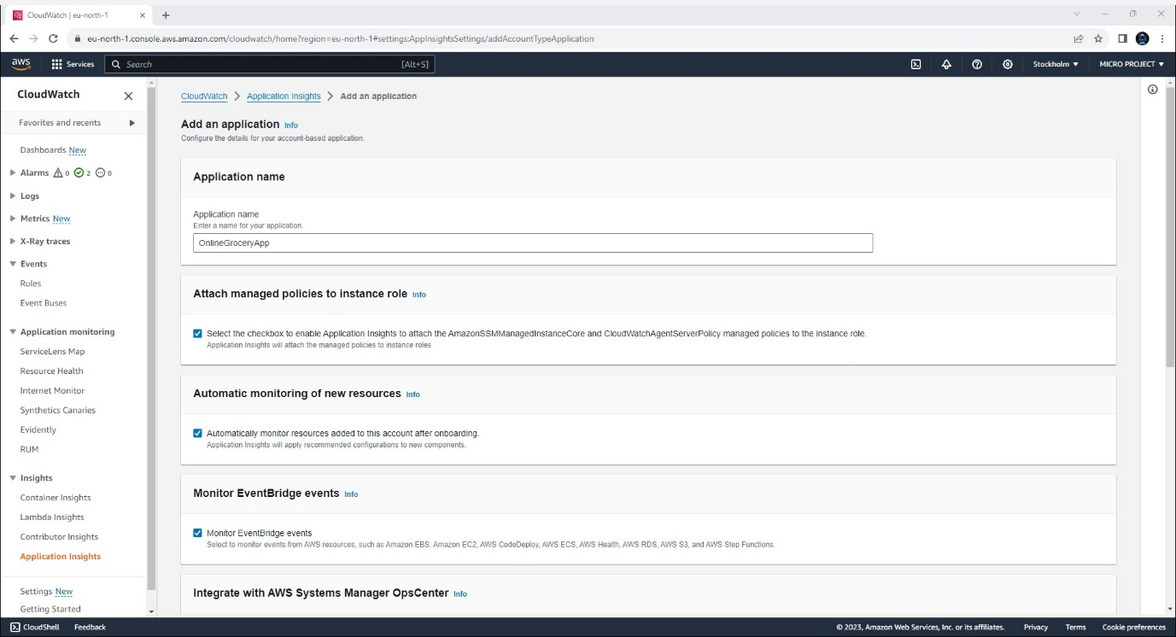Application insight creation

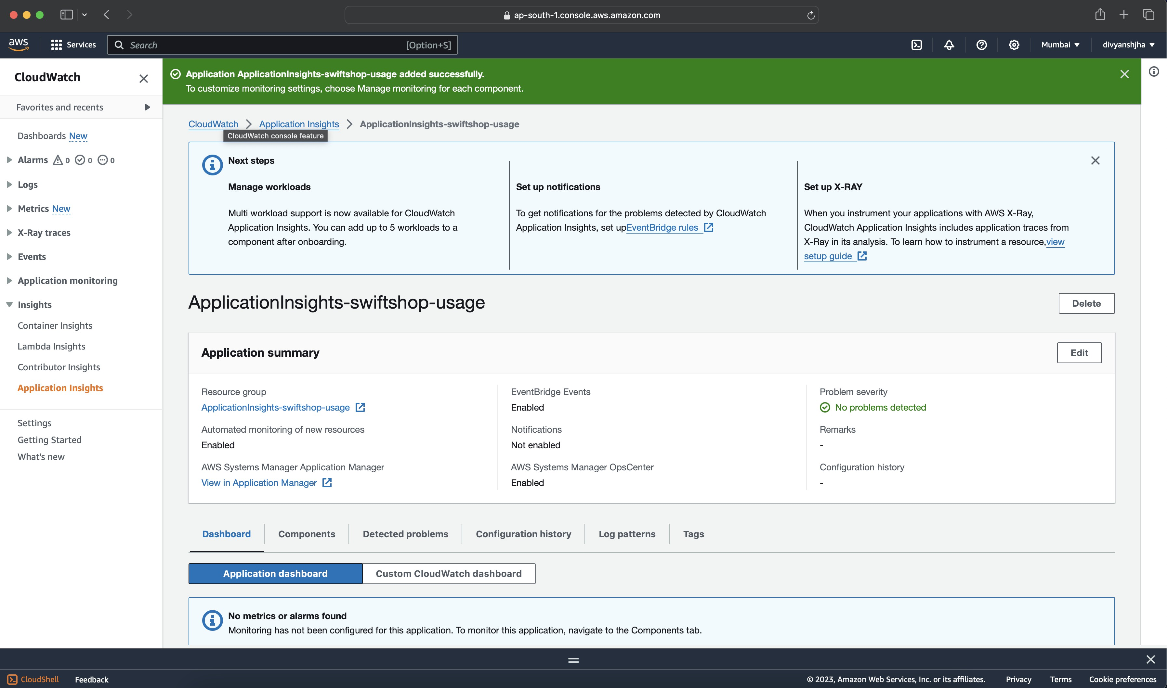Instance creation:

9. Showcase the ability to monitor the application's performance and troubleshoot issues.

**Troubleshooting:**

- Using `kubectl logs` to inspecting container logs.

- Monitoring resource utilization with `kubectl top`.

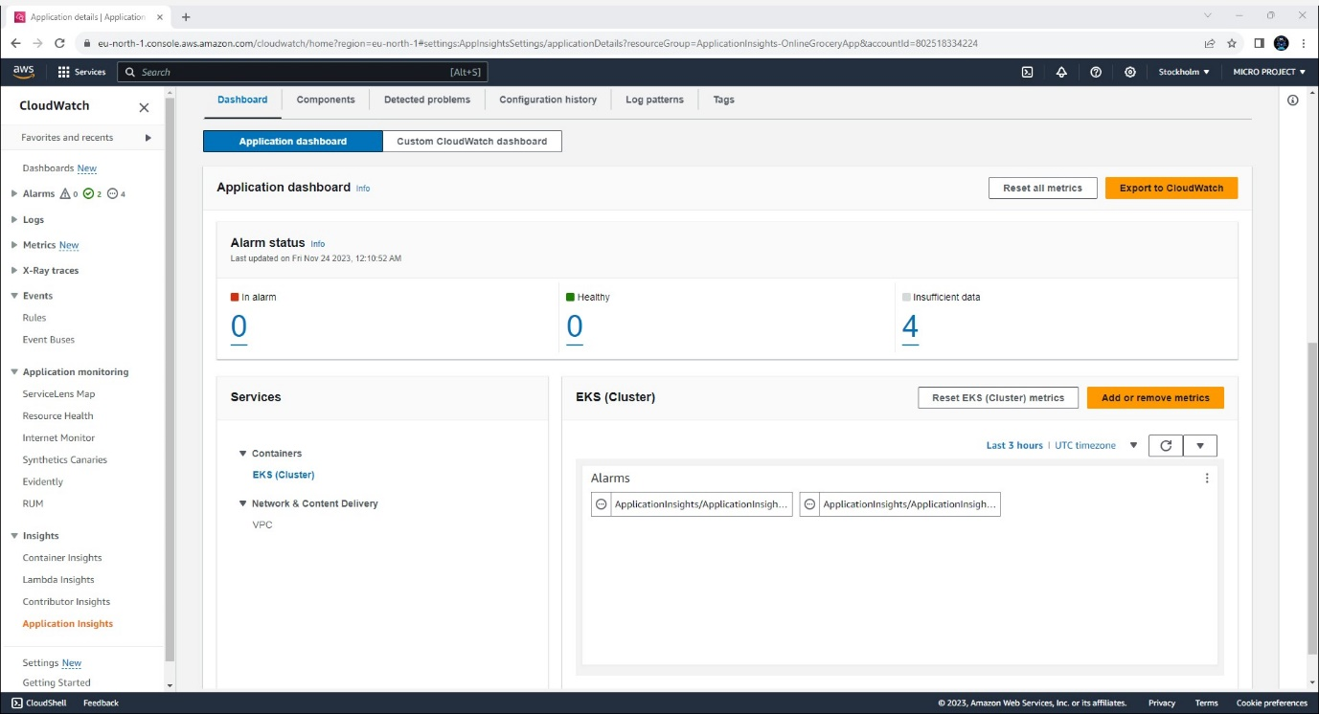- Implementing health probes for application reliability.

GitHub Link: <https://github.com/Hitendra-Sisodia/microservice-backend>

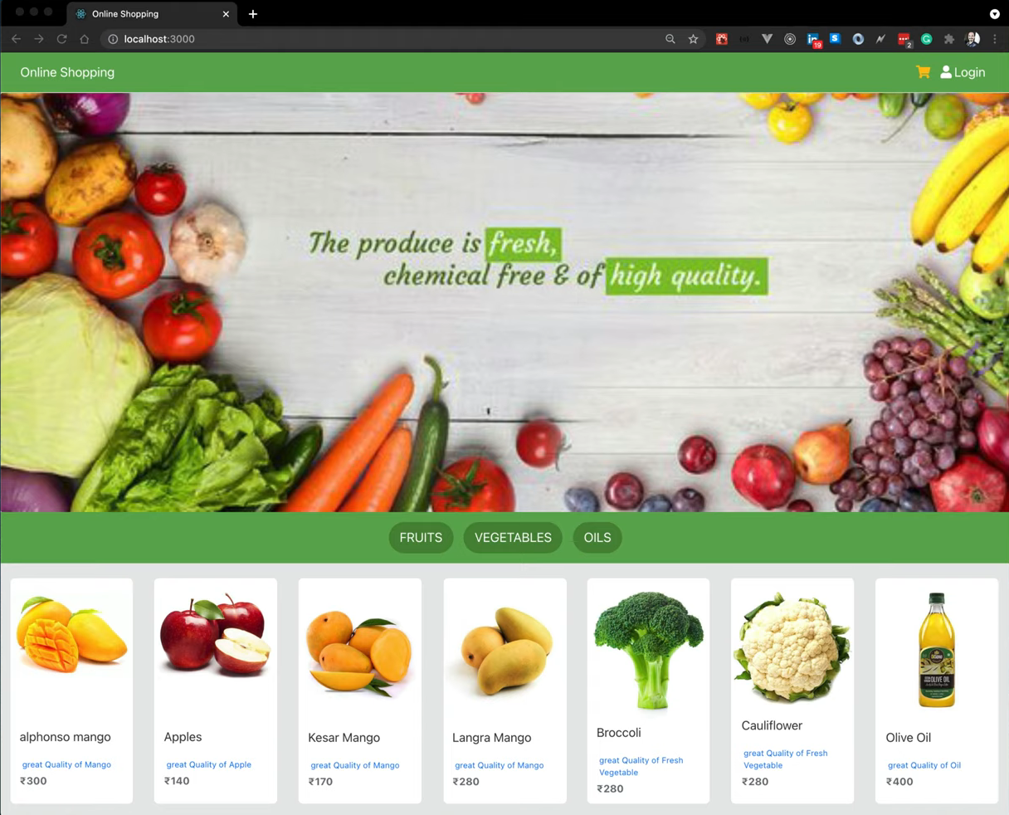  
Overview